Settings for Morpho Device:
- Install morpho device drivers & RD services in machine.
- Go to below path:
- Open ConfigSettings file in Notepad.
Make changes as mentioned below and save the file.
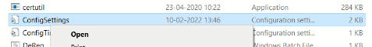
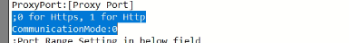
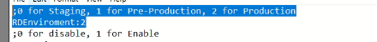
Check below settings. The RDEnviorment Mode should be 0

The CommunicationMode should be: 0

- Go to windows and open ‘services.msc’.
Restart the below listed 2 services of Morpho.

- Go to Chrome browser and typrchrome://flags
“Allow invalid certificates for resources loaded from localhost “ should be Enabled.
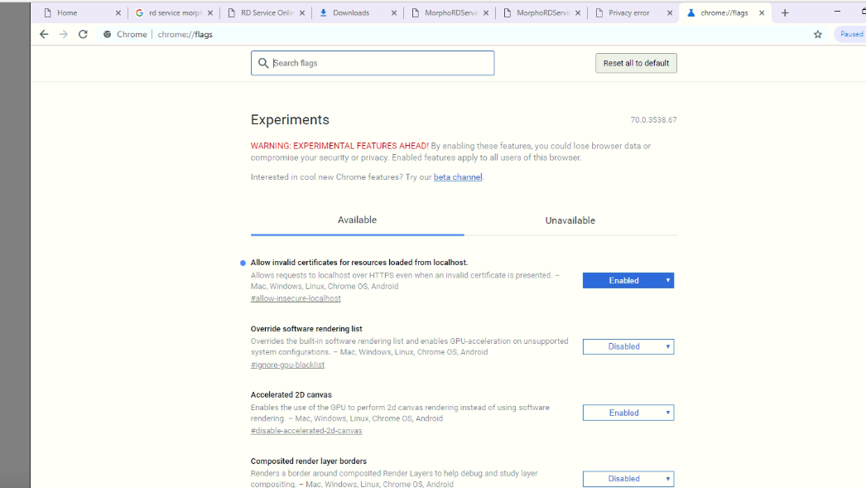

- Go to windows and open “Resource Monitor”.
The TCP Port of Morpho device should be 11100. Find below the screen shot for reference.

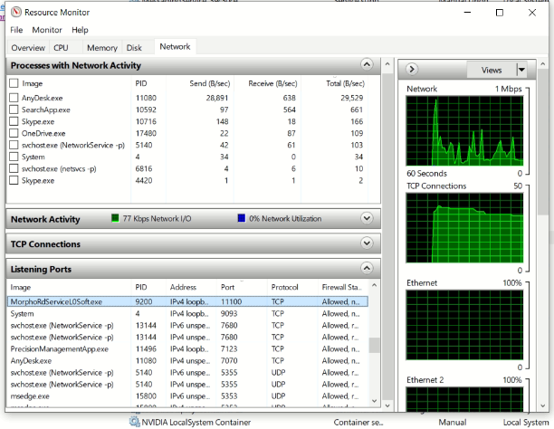

Settings for Mantra Device:

- Install Mantra device drivers & RD services in machine for fingerprint device.
- Go to below path :
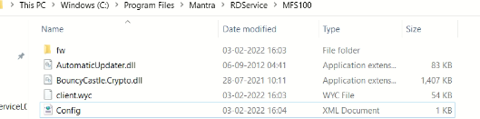

Open Config file in Notepad.
Set the value of env=”P” as sown below and save the file.
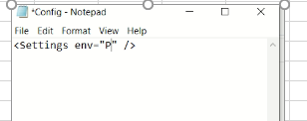

- Go to windows and open ‘services.msc’.
Restart the below listed “Mantra ADM” service.
If any other service of Mantra is running then please stop the same.

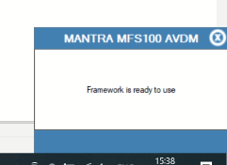
- Plug the device to machine. If all setup is successful then you should get the below popup.

